Name____________________
Board Game: Photosynthesis & Cellular Respiration

P__________Date__________
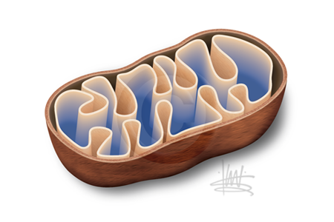
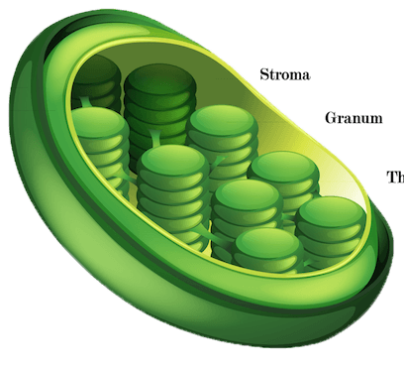
75 - 68 Mastery
67 - 60 Advanced
59 - 53 Meets
52 - 45 Approaching
44 or less Beginning

Assignment:
- You are a board game manufacturer, and you are assigned the task of creating a board game that will help students review everything they know about photosynthesis & cellular respiration in a fun and interesting way.

Requirements:
- Using note cards, game board, and colored pencils, create a photosynthesis/cellular respiration game.
- Design and decorate the game board.
- Make it neat, colorful, interesting, and creative.

______24 points Create 24 questions and answers about photosynthesis and cellular respiration.
- You must have 12 questions on photosynthesis AND
- 12 questions on cellular respiration.

______ 6 points Design/Decoration: Your game needs to be about photosynthesis & cellular respiration.
- You need at least 6 different pictures on your game board.

_______25 points Format:
- You need at least five (5) spaces with instructions such as:
“Skip a turn,” “Move 1 space forward,” “Move 2 spaces backwards” AND
- at least twenty (20) spaces with the instructions “Draw a Card.”

_______ 5 points Game Directions: Write your “How To Play” game directions on an index card.
- Include: 1. how many die, 2. what indicates when a player draws a card, 3. what the player should do if he/she answers the question correctly/incorrectly, 4. directions for special spaces such as what happens if you go to jail, 5. how to win (roll an exact number to the last space, or roll at least the number to the last space.)

_______15 points Creativity and Effort during the creation time in class.
- (ONE point will be deducted every time you need to be redirected during the creation time in class).
_______75 total possible points
