Name ________________________________
P. ____Date___________________________

Function of Plant And Animal Cell Organelles

1. Identify by writing if the organelle is found in a plant cell, animal cell or
both plant and animal cells.
2. Write a brief description of each cell organelle.

________________ ________________

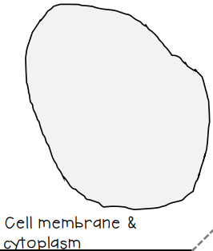
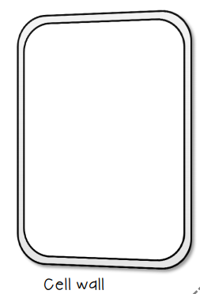

_______________________________ ________________________________
_______________________________ ________________________________

________________ ________________

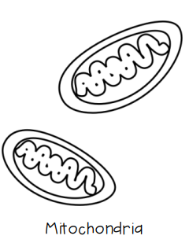
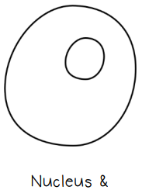
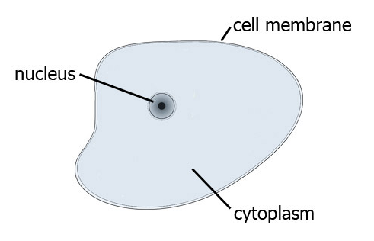

_______________________________ ________________________________
_______________________________ ________________________________

________________ ________________

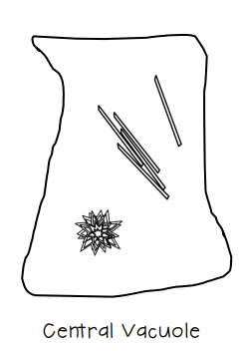
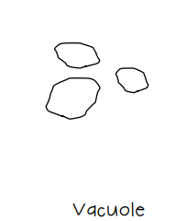

Large Vacuole

_______________________________ ________________________________
_______________________________ ________________________________

________________ ________________



 
 

