Name ____________________________

Period____Date____________________

Food Chains, Food Webs, and Energy Pyramid worksheet

- Using the following food chain, answer the questions below.
Grass Rabbit Fox

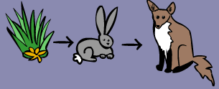

- What type of organism is the grass? _____________________________
- Which animal is a carnivore? __________________________________
- The fox is a _________________consumer.
- Which animal is an herbivore? ___________________________
- What would happen to the population of rabbits, if the population of foxes increased (got bigger)? Why? ____________________________________________________________________________________________________________________________________________________________________________

- Construct a food chain by writing the name (no pictures.) Label the producer, primary consumer, secondary consumer, and tertiary consumer.
An owl eats a snake, the snake eats a squirrel, the squirrel eats a nut.

- Using the food chain from question 2, construct an energy pyramid using words (not pictures.)

  - Which animal has the most amount of available energy? ____________________
  - Which animal has the least amount of available energy? ____________________

- Use the food web below to answer the questions.

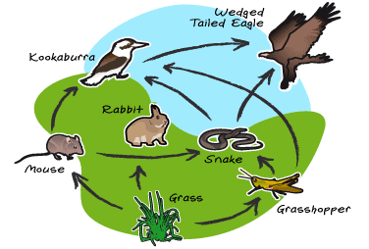
Berry bush
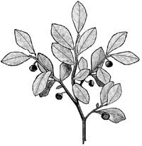

  - What are the producers? __________________________________________
  - What are the primary consumers? ___________________________________________
  - What are the secondary consumers? __________________________________
  - What is the tertiary consumer? ______________________________________
  - What organism is an omnivore?________________________________
  - What organisms are carnivores?___________________________________________
  - Construct one food chain using words (not pictures) that you see on the food web.

h. Using the FOOD WEB above, construct an energy pyramid using words (not pictures.)
Energy Flow Through the Ecosystem Study Guide

Word | Description/Definition | Example/Picture
Producer

Consumer

Herbivore

Omnivore

Carnivore

Decomposer

Food Chain

Trophic Level

Food Web

Energy Pyramid

