

Crust

E

**A**

**R**

**T**

**H**

**‘**

**S**

**L**

**A**

**Y  
E  
R  
S**

Continental Crust

Lithosphere

Oceanic Crust

Oceanic Crust



Lower Mantle



Asthenosphere

Convection Currents

Upper Mantle



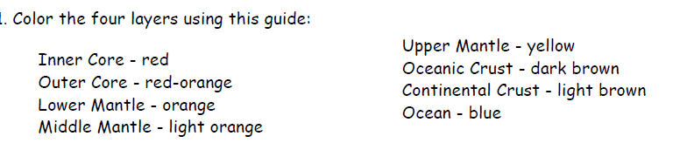

Inner Core

Outer Core