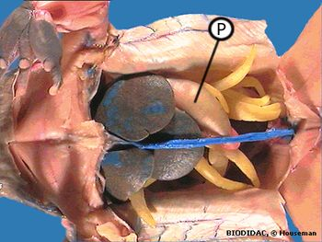

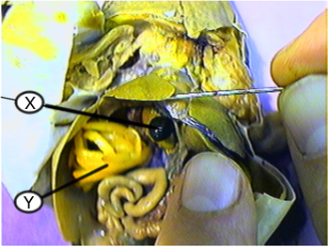

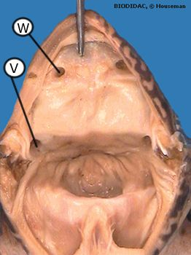

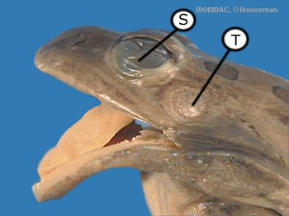

The function of the Eustachian Tubes are to what?

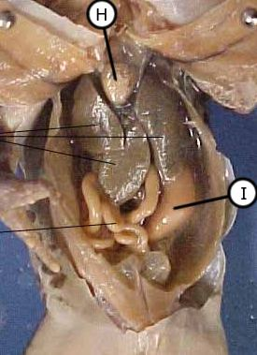

**J**

P=stomach

equalize

pressure

W=glottis

V=Eustachian tubes

S=nictitating membrane

T=tympanic membrane

X=gall bladder

Y=fat bodies

H=ventricle of the heart

I=stomach

J=liver

Eggs, sperm, and wastes all exit out of what structure?

The stomach belongs to which system?

Where does the glottis lead to?

Describe the vomerine teeth of a frog.

How do frogs store fat?

The largest organ in the frog’s body cavity is what?

2 small round teeth in the front upper mouth

lungs

lungs

liver

in fat bodies

digestive system

cloaca