Name _________________________
Period ___ Date_________________
Evaporation Lab
Question to investigate: Does adding energy increase the rate of evaporation?
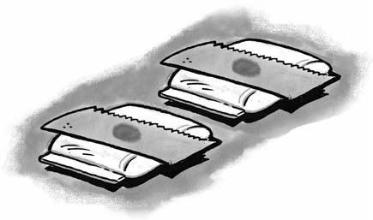
Materials for each group: 2 freezer pint size Ziploc bags, 250 ml beaker, hot water, room temperature water, 2 small squares of brown paper towel, 2 pipettes, 50 ml beaker of room temperature water
Procedure
  - Add room-temperature water from the faucet to a Ziploc bag until it is about ½ filled. Get as much air out as possible, and seal the bag securely. Lay the bag down flat. (this is your control)
  - Add hot water to a different Ziploc bag until it is about ½ filled—THE WHOLE BEAKER FROM THE BURNER (200 ml). Get as much air out as possible, and seal the bag securely. Lay the bag down flat. (this is your heat/energy source)
  - Place a small rectangle piece of paper towel on top of each Ziploc bag.
  - Put a small amount of room temperature water from the faucet in to your
50 ml beaker.
  - You and your partner each get a pipette.
  - Using your pipette, get a small amount of water from your 50 ml beaker.
  - Each of you, at the same time, place 1 DROP of water, from your pipette, on the center of each small piece of paper towel (at the same time.)
  - Observe for a total of 3 minutes-(LOOK AT THE CLOCK.) Compare the amount of water on each paper towel before, during, and after the 3 minutes.
  - During the 3 minutes, start DRAWING a LABELED diagram of your lab set-up. At the end of the 3 minute observation, finish your diagram by adding what each paper towel looked like.

ROOM TEMPERATURE HOT

- Name 2 variables that were controlled in this experiment.
1)________________________ 2)_______________________

- Does adding energy increase the rate of evaporation? YES NO What evidence do you have from the experiment to support your answer?
____________________________________________________________________________________________________________________________________________________________

- Explain, on the molecular level, why heating water increases the rate of evaporation from the paper towel.
(Hint: Discuss the attractions between water molecules and molecular motion)

____________________________________________________________________________________________________________________________________________________________

- When water evaporates do the water molecules themselves break apart or do whole water molecules separate from one another? Describe how water changes as it goes from its liquid form to its gas form.
_______________________________________________________________________________________________________________________________________________________________

- The wet paper towel from the beginning of class was not heated. Why did the water evaporate anyway?
_______________________________________________________________________________________________________________________________________________________________

EXIT TICKET:
- ___________________ to a ___________________
- During ___________________, the entire liquid changes form, whereas during ___________________ only the molecules at the surface change.
- ____________________________________________________________________________________________________________

