Name ___________________P ____ Date________
I CAN compare the types of cells…
Identify the differences of
prokaryotic & eukaryotic cells.

Eukaryotic vs. Prokaryotic

Directions: 1. Read the questions and follow the link or direction above the
question to find the answers.
2. Write your answers on this paper.

Go to this link: (or search “Different Cell Types” then click)
http://library.thinkquest.org/C004535/different_cell_types.html
1. What are the two main types of cells?

________________________ and _____________________

Eukaryotic Cells
Click on the blue rectangle to the left:
2. How do eukaryotic cells differ from prokaryotic cells?

3. What are organelles?

4. What are two types of eukaryotic cells? ____________ and _____________
Prokaryotic Cells
Click on the blue rectangle to the left:
5. What do prokaryotic cells lack and have few of?

lack:______________________________
few of:_____________________________

6. Name three examples of Name three major
prokaryotic cells. shapes of prokaryotic cells.

examples major shapes
1. ____________________ 1. ________________
2. ____________________ 2. ________________
3. ____________________ 3. ________________

7. What is different about a prokaryotic cell’s DNA?

(turn paper over)
8. Name four functions of prokaryotic cells?
1. _________________________________
2. _________________________________
3. _________________________________
4. _________________________________

Eukaryotic Cells
Click on the blue rectangle to the left:

THEN click on the blue rectangle to the left:
Eukaryotic Examples

9. List five examples of eukaryotic cells?

1.___________________________
2. ___________________________
3. ___________________________
4. ___________________________
5. ___________________________

When you have completed this assignment, you may explore:
other links on this site
OR
search interactive animations cell structure wiley and it will take you to Cell Structure at the following address:
http://www.wiley.com/legacy/college/boyer/0470003790/animations/cell_structure/cell_structure.htm

9. What are some examples of eukaryotic cells?

Below are pictures of eukaryotic cells from the animalia, plantae, fungi, and protista kingdoms.
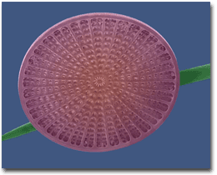  Picture of a Centric Diatom  (from the protista kingdom) | 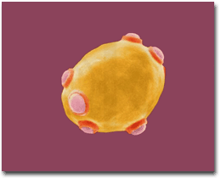  Picture of a Bread Yeast - S. cerevisiae  (from the fungi kingdom)
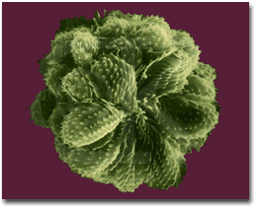  Picture of Golden Colonia Alga - Synura  (from the protista kingdom) | 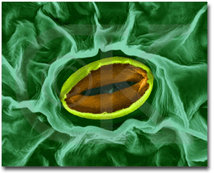  Picture of a Pea Leaf Stomata  (from the plantae kingdom)
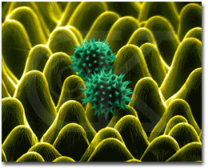  Sunflower Petal and Pollen Grains - Helianthus (from the plantae kingdom) | 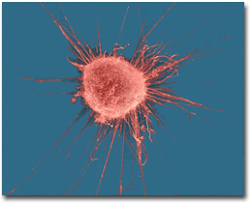  Human Breast Cancer Cell  (from the animalia kingdom)
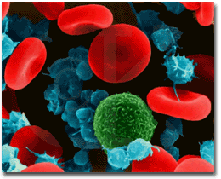  Human Red Blood Cells, Platelets, and T-lymphocytes (from the animalia kingdom) | 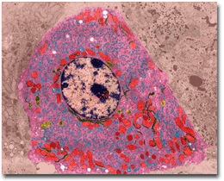  Human Liver Cell  (from the animalia kingdom)

