Energy Flow in an Ecosystem
Name _____________________________
Period____Date_____________________

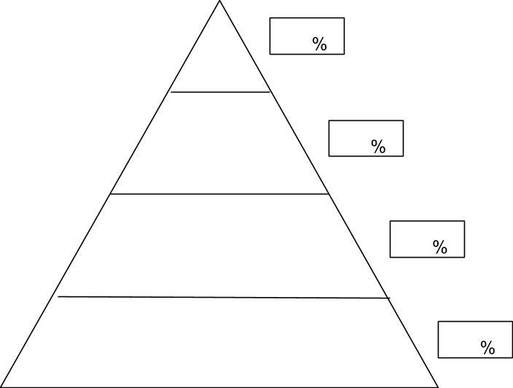
3. Label each tropic level as a producer or consumer. The consumer levels—label as primary, secondary or tertiary consumers.
2. Write the amount of available energy in each level.
1. Using your ½ sheet Marsh Food Web assignment, write the organism that fits in to each trophic level. (Do not include the raccoon or coyote on this pyramid.)
4. Only 10% of the energy available at each trophic level moves on to the next level. What happens to the other 90%?____________________________________________________________________________
_____________________________________________________________________________________
_____________________________________________________________________________________

