Energy Flow in an Ecosystem

Name _____________________________

Period____Date_____________________

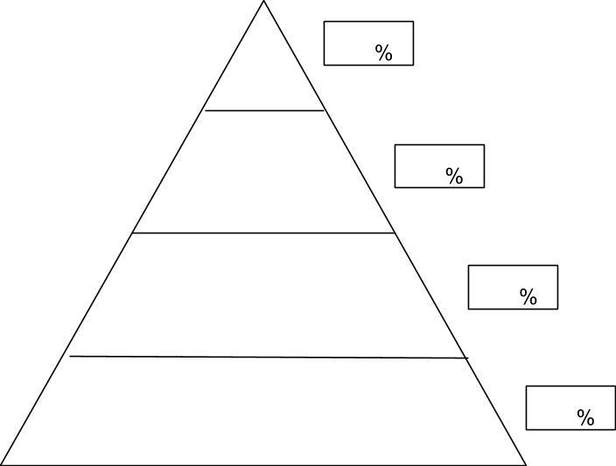

4. Only 10% of the energy available at each trophic level moves on to the next level. What happens to the other 90%?____________________________________________________________________________

_____________________________________________________________________________________

_____________________________________________________________________________________

3. Label each tropic level as a producer or consumer. The consumer levels—label as primary, secondary or tertiary consumers.

2. Write the amount of available energy in each level.

1. Using your Redwood Tree Canopy assignment, write the organism that fits in to each trophic level.