Name _____________________
P. ___Date_________________
Elodea Lab

Background: The aquatic plant, elodea (Genus: Anacharis) can commonly be found in lake habitats and is often used in aquariums. The purpose for using this plant is to study the internal structure of a leaf cell, more specifically the cell membrane, cell wall, and chloroplasts.

Materials:
- One elodea leaf - Colored Pencils - Paper towels -pipette
- water - Microscope - Slide and Cover slip

Procedures:
1. Obtain an elodea leaf from the main plant, and place it on a clean slide.
2. Place one drop of fresh water onto the leaf, and carefully place the cover slip on top of the leaf.
3. Place the slide under the microscope and observe under low power. You must get the leaf into focus before you can proceed. After the leaf is focused, turn your objective lens to medium power. Use the FINE adjustment to focus as clearly as you can. NOTE: You may need to move the slide around to find the best portion of the leaf to observe.
4. Turn the microscope to high power and draw what you see in the circle for “High Power”. Label the chloroplasts (the green objects), the cell wall, and the cell membrane (cell membrane may be hard to see) and the cytoplasm.
6. Record your observations next to your drawings.
7. Count the average number of chloroplasts per cell, and record the number in your data table.
8. Estimate the number of chloroplasts per leaf and record the number in your data table

Observations

Sketch:___________________________

Observations:

1. _______________________________________________

2. _______________________________________________

3. _______________________________________________

Magnification: _____________
Data:
Average number of chloroplasts per cell:

The estimated number of CELLS per leaf (the leaf is 3 cell layers thick): | 44,000 cells
Estimate of chloroplasts per leaf

Analysis Questions: Answer the following questions..
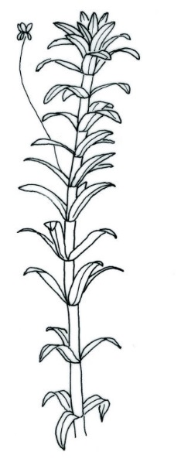
1. What is the role of chloroplasts in a plant?_______________________________________
2. About how many chloroplasts were in one leaf cell? _____________
How many did you estimate were in the entire leaf you observed? ____________
Based on these two estimations, predict how many chloroplasts would be in this elodea
plant. SHOW ALL YOUR MATH!

3. What does your estimation of chloroplasts in one plant tell you about the amount of energy a single chloroplast can make? (Do you think it makes a lot of energy? Why or why not?)
_____________________________________________________________________________________
_____________________________________________________________________________________
_____________________________________________________________________________________
4. Why do you think plants have so many leaves? _____________________________________________
_____________________________________________________________________________________

5. Write at least one other observation or question that you thought of during this lab._________________
_____________________________________________________________________________________
_____________________________________________________________________________________

