Draw a cave –side view—and label with the 3 zones,
CAVE ILLUSTRATION ASSIGNMENT INSTRUCTIONS AND EXAMPLES
entrance, twilight, and dark.
See assignment “Animals That Live in the Dark”.
Write names of at least THREE animals in the
appropriate zones.
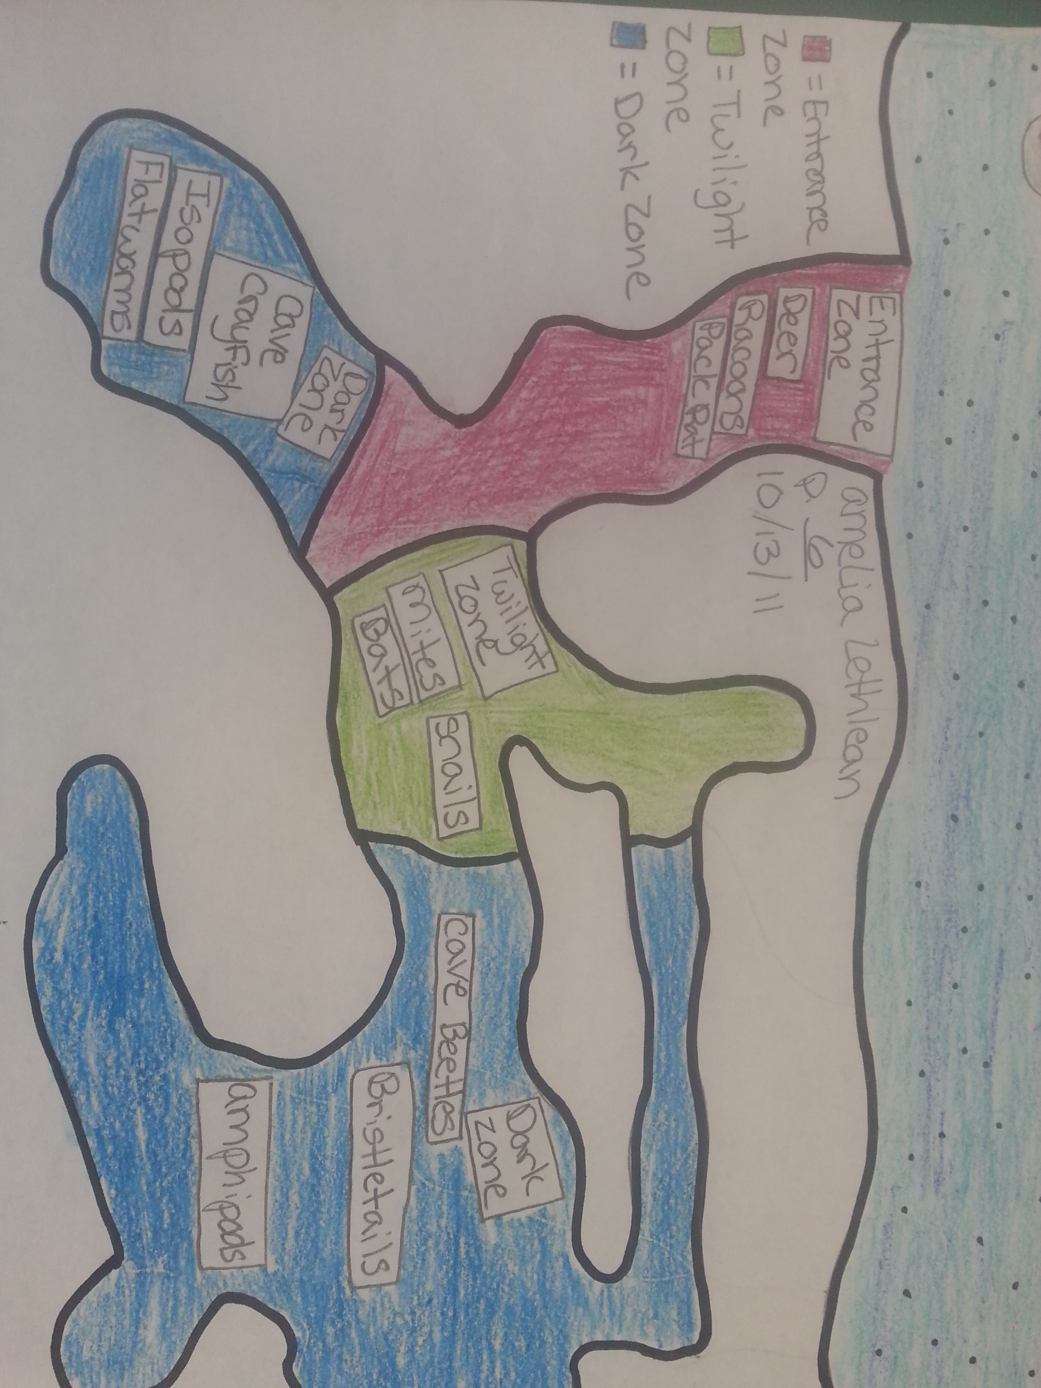
Color

