Name ______________________
I CAN describe the basic structure of the DNA molecule.
Period____Date______________
Complete a DNA Model of a Gene (modified)
1. Write your code here G G T C T A
2. Look on the back of this paper--What protein does your gene code for?
______________________________
3. What does this protein do?______________________________________________
__________________________________________________________________
4. On the DNA model, fill in the missing sugars and phosphates with letters S and P.
5. On your model, make the gene that is coding for the protein on the DNA double helix
strand. Some of you will only fill out one ladder, others will need to fill out two ladders.
I have already listed your code from #1 above down the left hand side of the ladder.
6. Now draw in the shape that is between the bases. Remember—there are 4 bases, so
there should be 4 different shapes. I already added the base shapes.
7. Now fill in the other base—remember the base-pairing rules A to T and G to C.
8. Color all the A bases one color, color all the T bases a different color, color all the G bases another color and all the C bases another color.
9. Then cut out the DNA model. Some of you will need to tape the two ladders together.— (do NOT cut off the tab—“glue or tape”)
10. Write your name and period on the back of your DNA model and turn it in with this completed worksheet.
Look in your book to complete the following: starting on page 128

11. The structure of DNA is called a __________________________________.

12. DNA stands for the words ___________________________________________.

13. The definition of DNA is: (copy from the glossary)

_______________________________________________________________________

_______________________________________________________________________

_______________________________________________________________________

14. A nucleotide is a subunit of DNA consisting of one of four bases and
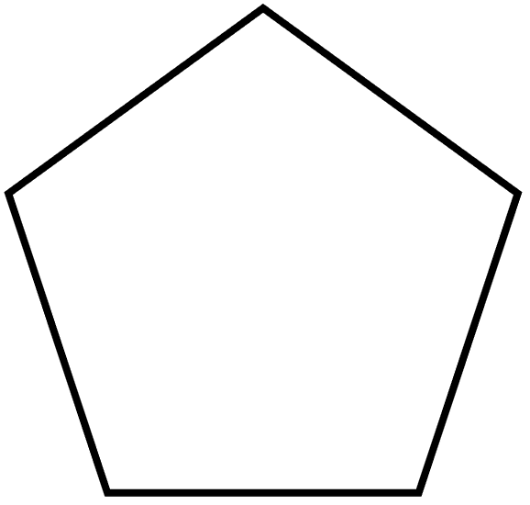
______________________
S

______________________
P

15. The four bases in DNA are: (page 128—write out the names of the bases)

_____________________ which is complementary to ______________________

_____________________ which is complementary to ______________________
GGTCTA
Tells the ribosome to make the hormone melatonin, (meləˈtōnən), which helps regulate sleep and wake cycles.

AATGCCATGATA
- Tells the ribosome to make myosin, (mye-oh-sin) the main protein that makes up muscle cells

TGCCATCGA
- Tells the ribosome to make hemoglobin, (hee-moe-glow-bin) the protein that carries oxygen throughout the body

GGCTATCGA
- Tells the ribosome to make an antibody protein, which protects the body from infection

GGATCC
- Tells the ribosome to make pepsin, a protein that speeds up digestion of food

GTACTGACGACC
- Tells the ribosome in a plant cell to make ethylene, (eth-i-lean) a protein which makes fruit ripen faster

TAACTG
- Tells the ribosome in a plant cell to make auxin, (ox-in) a protein which makes the plant turn towards the sun

GTCATC
- Tells the ribosome to make serotonin, (sare-uh-toe-nin) a hormone protein which scientists think helps people feel happier

AACTGAAGC
- Tells the ribosome to make cortisol, (kore-ti-sol) a protein that regulates changes in the body due to stress (for example, cortisol helps lower blood pressure when it starts to rise from a stressful situation)

