Name _________________________
DNA EXTRACTION LAB

P. ____Date____________________
PROCEDURE:

Fill in the observations during the experiment to describe what it looks like at each step.
1. Collect saliva (no mucus) in the  cup. You will need at least 10 ml. | Observation:
2. Add a very SMALL scoop of salt to your cup (use scoopula) and  SWIRL until all the salt is dissolved. | Observation:
3. Add 2 drops of liquid soap and  SWIRL until well mixed.  4. Let the mixture sit for 5 minutes. | Observation:
5. Pour the mixture into the test tube, up to the first line (apx. ¼ full). | TEACHER CHECKPOINT!  Get teacher stamp BEFORE moving on:  ________________________________________  teacher signature
6. The teacher will add a very small  scoop of enzymes (meat tenderizer) to the test tube after signing your check-point.  7. Stir GENTLY with WOODEN  STICK.  Be careful! If you stir too hard,  you’ll break up the DNA, making it  harder to see. | Observation:
8. TILT your test tube.  9. SLOWLY pour rubbing (isopropyl)  alcohol into your test tube up to  the second line (apx. half full). | Observations:
10. Alcohol is less dense than water, so it floats on top.  Look for clumps of white stringy stuff where the water and alcohol layers meet. | TEACHER CHECKPOINT!  Get your teacher’s stamp BEFORE moving on:  ________________________________________  teacher signature
11. DNA is a long, stringy molecule.  The salt that you added in step #1  helps it stick together.  Observe the clumps of tangled DNA molecules! | Observation- describe what your DNA looks like:
12. You can use a wooden stick or paper clip to collect your DNA AND place it in an Eppendorf tube and close the lid tightly.  13. You can thread a piece of string  through the Eppendorf tube and  wear your DNA as a necklace. | 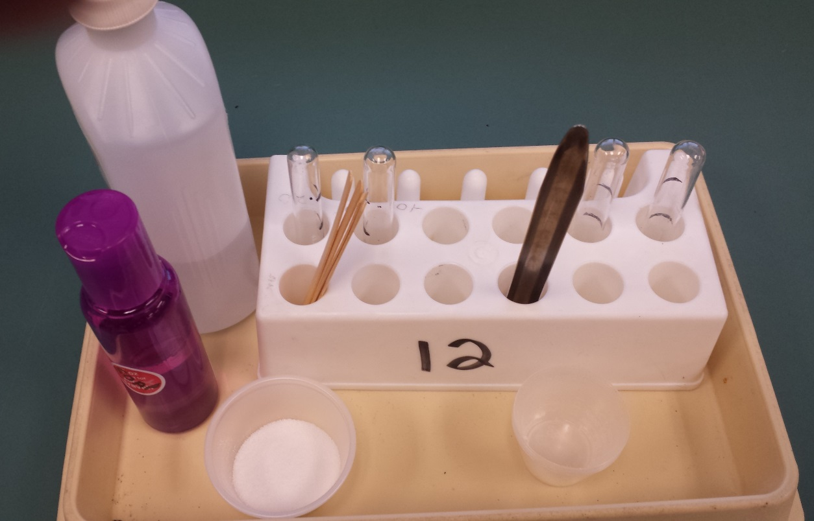
14. Clean up your station:
*Rinse test tube with clean water from the sink.
*Then dip and rinse in the bleach solution.
* Then dip and rinse in the bucket of clean water.
Make sure your station looks just like it did when you first sat down at this lab.

