Name ____________________________
Period____Date____________________

Predicting Earthquakes and Volcanoes
Holt pages 205-207 and pages 234-235

Earthquake Hazard and Forecasting
1. ___________________________measures how prone an area is to experiencing earthquakes in the future. This level is determined by _________and _____________seismic activity.
2. In Figure 1 below and on page 205--Oregon has a ___________earthquake-hazard level.
(high or low)
3. It is difficult to predict when and where earth-
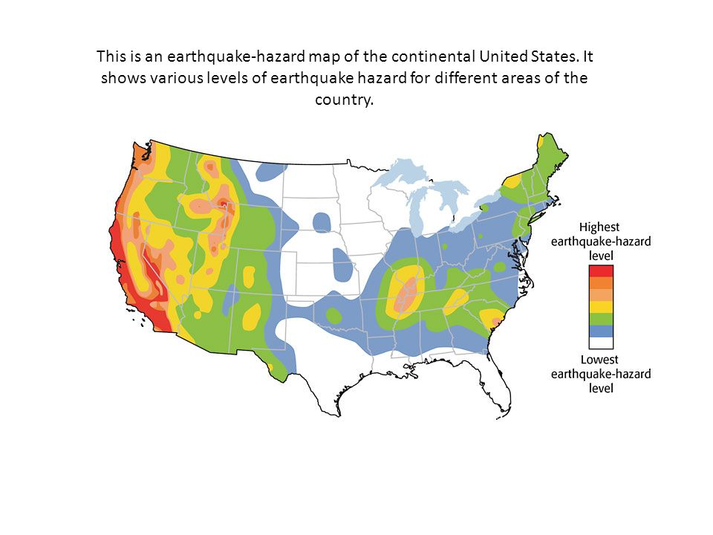
quakes will __________ and how _________ they will be.
Figure 1
4. The strength of earthquakes is related to how
__________________________________________.
Figure 2
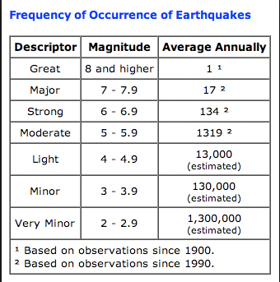
5. Generally, with each step down in earthquake magnitude, t the number of earthquakes per year is about ____times
greater.
6. Scientists use these statistics to make
___________________about the ______________,
___________________, and ___________________
of future earthquakes.
7. The ______________________________states that sections of active faults that have had relatively few earthquakes are likely to be the sites of _______________ earthquakes in the future.
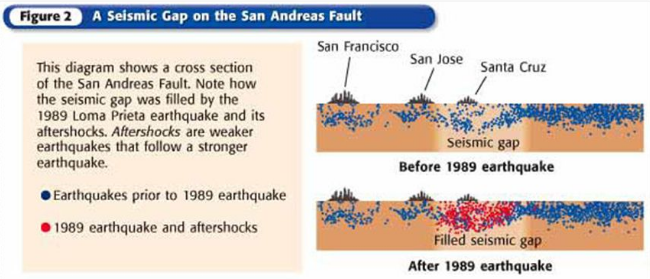
8. Scientists use seismographs to
locate epicenters of earthquakes to
identify areas of _______________
earthquakes.

Predicting Volcanic Eruptions (pg 234-235)
9. Scientists classify volcanoes based on their __________________histories and how likely they will erupt again to help them ________________volcanic eruptions.
10. Define the following:
Extinct volcanoes: _________________________________________________________
_______________________________________________________________________
Dormant volcanoes: ________________________________________________________
_______________________________________________________________________
Active volcanoes: __________________________________________________________
_______________________________________________________________________
11. Scientists use different instruments to predict volcano eruptions.
a. ___________________help determine when magma is moving beneath a volcano. When magma moves upward, it causes _____________to shift and rumblings inside the volcano increase.
b. __________________helps detect small changes in the angle of the slope of the volcano. When magma pushes against the inside of the volcano, it bulges and the angle becomes steeper.
c. The outflow of ______________________help with the predictions too. A spectrometer measures gases coming from inside a volcano. When the gas emissions increase—go up, it is an indicator that an eruption is nearing.
d. _____________________images allow scientists to measure changes in _______________________over time. If the temperature is getting hotter, it is an indication that magma is pushing closer to the surface.

