DIGESTION SYSTEM Name _______________ P. ______

1. (pg 570) Which liquid digests starch into glucose? ___________
I CAN describe the parts, functions, and the relationship of the organs in the digestive system.

2. (pg 570) What is the wave like muscle action in
the esophagus called? ______________________

3. (pg 571) Which organ makes acid soup out of food?_____________
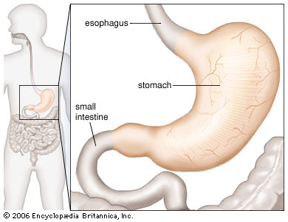
4. (pg 572) Which organ absorbs the digested food into the

bloodstream? ___________________

5. (pg 572) Which organ makes the acid soup non-acidic?

________________________________

6. (pg 573) Which organ makes bile? ___________________

7. (pg 573) What fluid dissolves fat? _____________

8. (pg 574) Which organ absorbs the water out of the undigested parts of the

food? ____________________________

9. The “good” guys in the large intestine are microscopic ____________.

10. pg. 575) Damage to the stomach lining causes painful ______________.
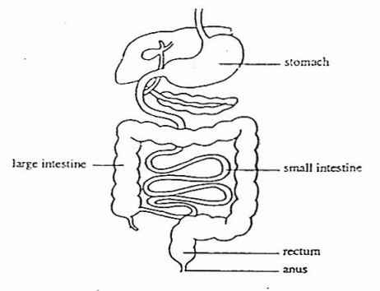
WORD BANK
ulcers bile saliva
liver peristalsis bacteria
pancreas stomach
small intestine large intestine

Some more on the DIGESTIVE SYSTEM
I CAN describe the parts, functions, and the relationship of the organs in the digestive system.

1. (pg 570) Saliva contains an ____________that begins the chemical digestion of

carbohydrates.

2. (pg 570) Carbohydrates have to be digested into ________________ before

being absorbed into the blood.
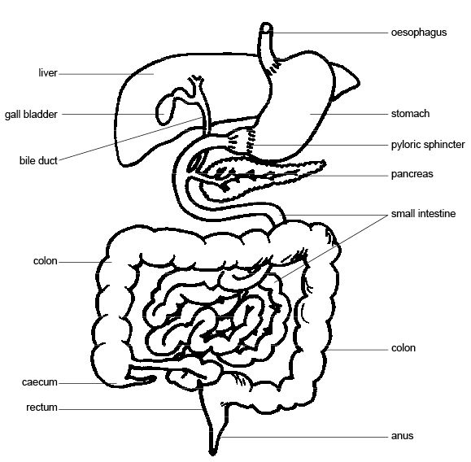

3. (pg. 571) Chemical and physical digestion in the stomach stomach turns the acid soup into

_____________________.

4. (pg. 572) The organ that does the most chemical

digestion is the _________________

5. (pg. 572) Which organ has villi to absorb digested nutrients into the blood?

____________________________
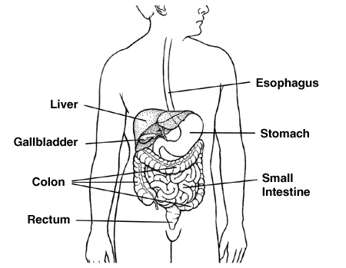
6. (pg 572) Which organ makes many digestive enzymes

for the intestine? __________________

7. (pg 573) Fats and oils stay in large, indigestible
globs until dissolved by

_________________ made in the liver.

8. (pg 574) Which organ absorbs water into the blood from undigested food?

______________________

9. The “good guys” in the large intestine are _____________________.

10. (pg 575) An open sore in the stomach lining is called an ________________.

WORD BANK: ulcers bile enzyme pancreas small intestine
glucose bacteria chyme large intestine

