Name__________________________
Period____Date__________________

DESIGN YOUR OWN FLOWER

Fill out your preferences:
Your favorite color:_________________________
Your favorite shape:_________________________
A smell you like:____________________________
Your favorite snack:_________________________
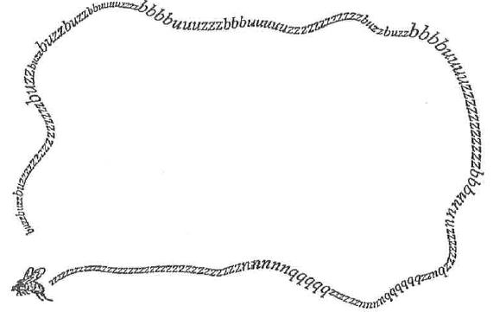

Imagine you are a flower adapting to your preferences. In the area above, draw a “designer” flower to suit your preferences. Then, describe why the flower you created would appeal to you.
________________________________________________________________________________________________________________________________________________________________________________________________________________________________________________________________________________________________________________________________________________________________________________________________________________

