**DO NOT WRITE ON THIS PAPER!**

**DO NOT TAKE THIS PAPER!**

MCj04298070000[1]***MCj04298070000[1]***

***Crazy Convection Currents Lab***

**Objective: Visualize and explain how convection currents occur.**

**Question: What do convection currents do to materials in the mantle?**

**Safety: Use the hot pads to handle hot materials.**

|  |
| --- |
| **Materials:** |
| 1- hot plate (low-medium setting) |
| 1 -200 ml of water |
| 1- 250 ml beaker |
| 1- portion of soap and pepper |
| 1- Hot pad |
| 1- Timer or clock with a second hand |

**Exploration Procedure:**

1. Fill your beaker with 200 ml of water.
2. Put 2 drops of soap and ¼ tsp. pepper in your beaker.
3. After about one minute, record your observation of what happened to the pepper.
4. Place the beaker gently onto the hot plate and start the timer for **10 minutes**.
5. While you are waiting, label the interior of the Earth, and with your group, discuss the answer to the last statement on the lab paper.
6. **After the 10 minutes, look at your beaker and record observations.**

**Note: WATCH all the pepper and then try following just ONE pepper.**

1. The teacher will gently and **CAREFULLY** remove the beaker with a hot pad from the hot plate and set it aside.
2. **DO NOT DUMP IT OUT YET!!**

9. **WAIT** for the teacher to tell you when to DUMP out and clean the beaker.

Name________________________

Period___Date_________________

***CRAZY CONVECTION CURRENTS LAB SHEET***

|  |  |
| --- | --- |
| **PREDICTIONS**  **OBSERVATIONS** | **a. What will happen to the soap and pepper as heat is added to the fluid?** |
| **b. What will happen when the soap and pepper travel away from the heat?** |
| **After you placed the pepper and soap into the beaker.** | **a. What happened to the pepper after adding it to the beaker and WAITING ABOUT ONE MINUTE?** |
| **After 10 minutes on the heat source** |  |

**Explanation Diagram: In the diagram below:**

**-Include *arrows* showing the convection currents.**

**-Complete the statements using these words: asthenosphere, core, lower**

**mantle**

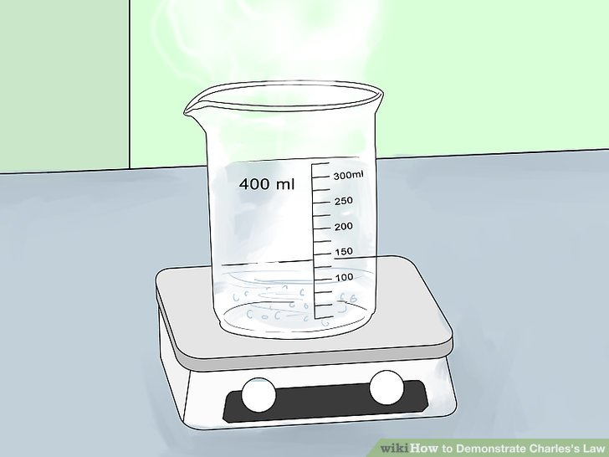

**1. The hot plate represents the _______________ layer of Planet Earth (where is the heat coming from?)**

**2. The beaker represents the _________________ layer of Planet Earth.**

**3. The water, soap, and pepper represent the magma found in the _________________ layer of Planet Earth.**

**Explanation Conclusion:**

**In the boxes provided, label the Earth diagram with the correct word(s), study it, and complete the conclusion below.**

**1. Label the INNER CORE 6. Label the VOLCANO**

**2. Label the OUTER CORE 7. Label the ASTHENOSPHERE**

**3. Label the CONVECTION CURRENTS 8. Label the LITHOSPHERE**

**4. Draw the PARTICLES on the C. Current 9. Label the CRUSTS**

**in the small boxes**

**5. Label the MANTLE**

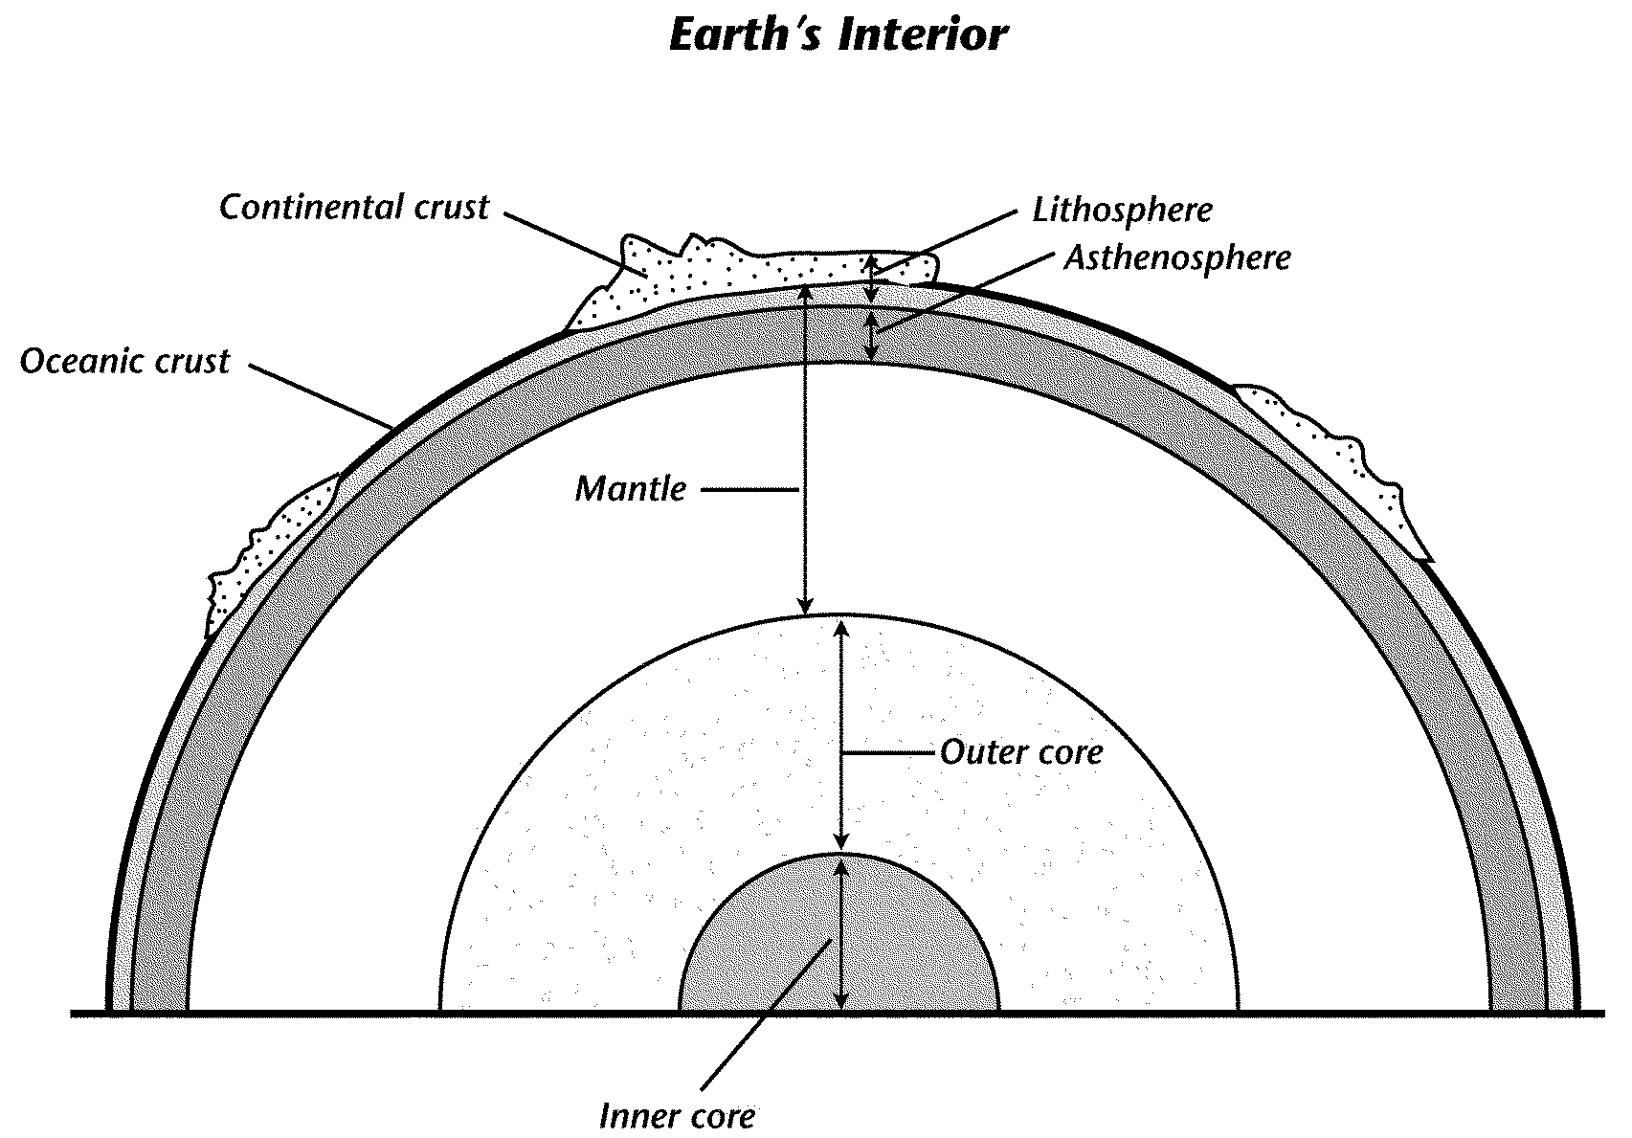

**Construct a conclusion about how convection currents move materials through the mantle.**

**Include these words: more dense, less dense, hotter, cooler, rising (or rise up) and sinking (or sink)**

_________________________________________________________________________________________________________________________________________________________________________________________________________________________________________________________________________________________________________________________________________________________________________________________________________________________________________________________________________________

____________________________________________________________________________________________________________________________________________________________________________________________________________________________________________________________________________________________________________________________________________________________________________________