ANSWER KEY
I CAN describe the basic structure of the DNA molecule.
Name________________
P. ___ Date___________
Ch 6 S. 1a Genetics: Structure of DNA

gene A gene is a DNA sequence which gives instructions for cell processes
and for building cell structures.

Deoxyribonucleic DNA stands for Deoxyribonucleic Acid
Acid Deoxyribose is the type of sugar found in DNA, nucleic means that the DNA is found in the nucleus.
Chromosome
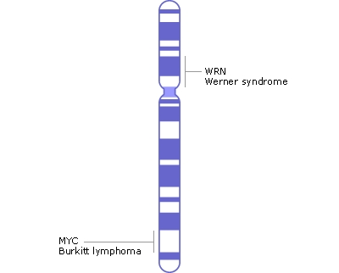

DNA is found in the nucleus, in a linear shape called a chromosome (DNA + protein)
DRAW A PICTURE of a chromosome

nucleotide DNA is composed of subunits called nucleotides.

sugar, phosphate, Each nucleotide is composed of sugar, phosphate, and nucleotide base.
nucleotide base DRAW A PICTURE
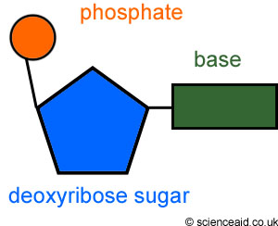
A, T, C, G

Two strands of DNA bond together to form a twisted ladder or
double helix
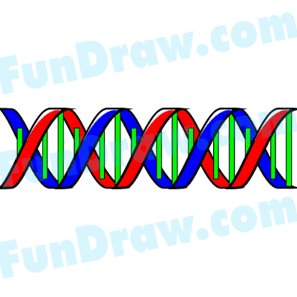

double helix a shape that we recognize as DNA.

Double helix On the double helix or twisted ladder the rails of the ladder are made from twisted ladder alternating sugar and phosphate; the rungs of the ladder are made from
nucleotide base-pairs.
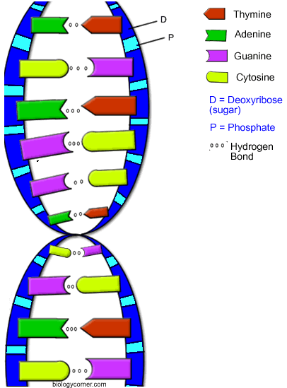
draw picture

A, T, G, C The nucleotide bases on DNA are adenine (A), thymine (T), guanine (G), and
cytosine (C).

base-pairing rules They always bond according to the base - pairing rules A-T and G-C.
draw picture
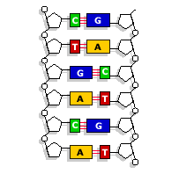

Name________________
P. ___ Date___________

Ch 6 S. 1a Genetics: History of DNA

Watson James B. Watson Ph.D. (22 yrs.) traveled to London, England to study
the secret structure of DNA.

Crick Francis Crick (32 yrs.) wanted to discover the structure of DNA.
Crick was a loud talker.

Wilkins Maurice Wilkins was using X-ray scatter to try and see DNA.

Franklin Rosalind Franklin worked with Maurice.

Franklin used x-ray crystallography to construct the positions of the
molecules.

She discovered that the sugar & phosphate are the backbone of DNA, and lies on

the outside of the molecule and the helical structure of DNA has

two strands. She was published but died before the Nobel Prize was given to Watson and Crick.

1953 In 1953 Watson and Crick figure out how the parts of DNA fit together.

Nobel prize Crick, Watson, & Wilkins shared the Nobel Prize _ in 1963.
1963
This discovery was the beginning of many new discoveries.

