I CAN describe the basic structure of the DNA molecule.
Name________________
P. ___ Date___________
Ch 6 S. 1a Genetics: Structure of DNA—CORNELL NOTES

A ______is a DNA sequence which gives instructions for cell processes
and for building cell structures.

DNA stands for __________________________
Deoxyribose is the type of sugar found in DNA, nucleic means that the DNA is found in the nucleus.

DNA is found in the nucleus, in a linear shape called a ____________.
DRAW A PICTURE of a chromosome

DNA is composed of subunits called ______________.

Each nucleotide is composed of a __________, ___________, and ______. DRAW A PICTURE.

Two strands of DNA bond together to form a twisted ladder or
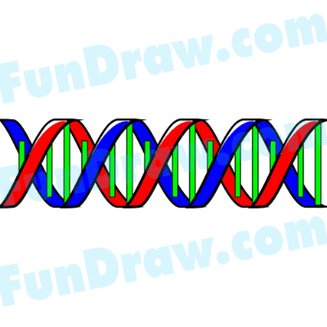

_________________ ______________, a shape that we recognize as DNA.

On the ________ _____________ or __________ ________________the rails of the ladder are made from alternating sugar and phosphate; the rungs of the ladder are made from nucleotide base-pairs.
draw picture

The nucleotide bases on DNA are ________________, __________________

_____________________, and ___________________

They always bond according to the _________ - ________ _______: A-T and G-C.
draw picture

Name________________
P. ___ Date___________

Ch 6 S. 1a Genetics: History of DNA

James B. _________, Ph.D. (22 yrs.) traveled to London, England to study
the secret structure of DNA.

Francis ______________, (32 yrs.) wanted to discover the structure of DNA.
Crick was a loud talker.

Maurice _______________ was using X-ray scatter to try and see DNA.

Rosalind _______________ worked with Maurice.

Franklin used x-ray crystallography to construct the positions of the

_________________.

She discovered that the sugar & phosphate are the backbone of DNA, and lies on

the ________________of the molecule and the helical structure of DNA has

____ strands. She was published but died before the Nobel Prize was given to Watson and Crick.

In ______ Watson and Crick figure out how the parts of DNA fit together.

Crick, Watson, & Wilkins shared the _________ ____________ in 1963.

This discovery was the beginning of many new discoveries.

