Name________________

P. ___ Date___________

**Write key word(s) in this column.**

***Example***:

**WATSON**

Ch 6 S. 1a Genetics: History of DNA

James B. **_________**, Ph.D. (22 yrs.) traveled to London, England to study

the secret structure of DNA.

Francis **______________**, (32 yrs.) wanted to discover the structure of DNA.

Crick was a loud talker.

Maurice **_______________** was using X-ray scatter to try and see DNA.

Rosalind _______________ worked with Maurice.

Franklin used x-ray crystallography to construct the positions of the

_________________.

She discovered that the sugar & phosphate are the backbone of DNA, and lies on

the ________________of the molecule and the helical structure of DNA has

____ strands. She was published but died before the Nobel Prize was given to Watson and Crick.

In ______ Watson and Crick figure out how the parts of DNA fit together.

Crick, Watson, & Wilkins shared the **_________** **____________** in 1963.

This discovery was the beginning of many new discoveries.

Name ______________________________

P. ____Date_________________________

Structure of DNA Flow Chart

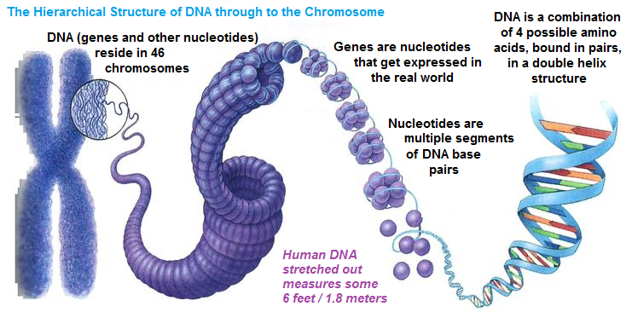

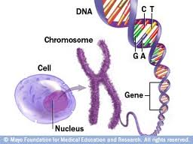

Type of structure

Human cells have 23 pairs, one from mom and one from dad

