Name________________

P. ___ Date___________

Ch 6 S. 1a Genetics: History of DNA

Watson James B. ***Watson*** Ph.D. (22 yrs.) traveled to London, England to study

the secret structure of DNA.

Crick Francis ***Crick*** (32 yrs.) wanted to discover the structure of DNA.

Crick was a loud talker.

Wilkins Maurice ***Wilkins*** was using X-ray scatter to try and see DNA.

Franklin Rosalind ***Franklin*** worked with Maurice.

Franklin used x-ray crystallography to construct the positions of the

***molecules***.

She discovered that the sugar & phosphate are the backbone of DNA, and lies on

the ***outside*** of the molecule and the helical structure of DNA has

***two*** strands. She was published but died before the Nobel Prize was given to Watson and Crick.

1953 In ***1953*** Watson and Crick figure out how the parts of DNA fit together.

Nobel prize Crick, Watson, & Wilkins shared the ***Nobel Prize*** **_** in 1963.

1963

This discovery was the beginning of many new discoveries.

Name ______________________________

P. ____Date_________________________

Structure of DNA Flow Chart

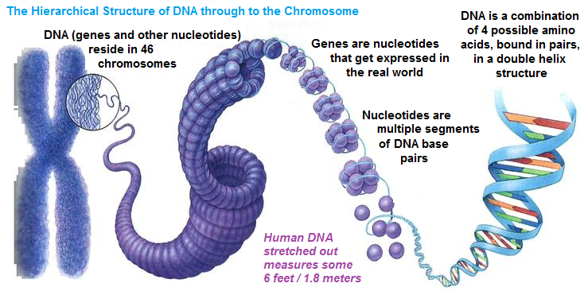

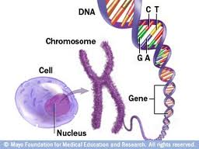

pair of chromosomes

double helix

Type of structure

cell

nucleotide

gene

nucleus

Human cells have 23 pairs, one from mom and one from dad

protein

DNA

