ANSWER KEY
I CAN describe the basic structure of the DNA molecule.
Name________________
P. ___ Date___________
Ch 6 S. 1a Genetics: Structure of DNA

gene A gene is a DNA sequence which gives instructions for cell processes
and for building cell structures.

Deoxyribonucleic DNA stands for Deoxyribonucleic Acid
Acid Deoxyribose is the type of sugar found in DNA, nucleic means that the DNA is found in the nucleus.
Chromosome
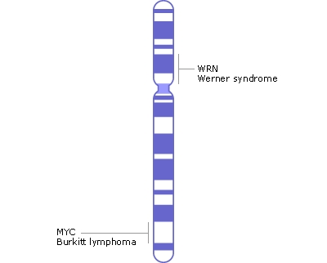

DNA is found in the nucleus, in a linear shape called a chromosome (DNA + protein)
DRAW A PICTURE of a chromosome

nucleotide DNA is composed of subunits called nucleotides.

sugar, phosphate, Each nucleotide is composed of sugar, phosphate, and nucleotide base.
nucleotide base DRAW A PICTURE
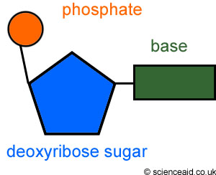
A, T, C, G

Two strands of DNA bond together to form a twisted ladder or
double helix
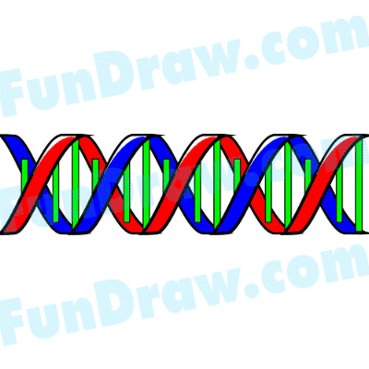

double helix a shape that we recognize as DNA.

Double helix On the double helix or twisted ladder the rails of the ladder are made from twisted ladder alternating sugar and phosphate; the rungs of the ladder are made from
nucleotide base-pairs.

A, T, G, C The nucleotide bases on DNA are adenine (A), thymine (T), guanine (G), and
cytosine (C).

base-pairing rules They always bond according to the base - pairing rules A-T and G-C.
draw picture

