I CAN describe the basic structure of the DNA molecule.
Name________________
P. ___ Date___________
Write key word(s) in this column.

Example:
GENE
Ch 6 S. 1a Genetics: Structure of DNA—CORNELL NOTES

A ______is a DNA sequence which gives instructions for cell processes
and for building cell structures.

DNA stands for __________________________
Deoxyribose is the type of sugar found in DNA, nucleic means that the DNA is found in the nucleus.

DNA is found in the nucleus, in a linear shape called a ____________.
DRAW A PICTURE of a chromosome

DNA is composed of subunits called ______________.

Each nucleotide is composed of a __________, ___________, and ______. DRAW A PICTURE.

Two strands of DNA bond together to form a twisted ladder or
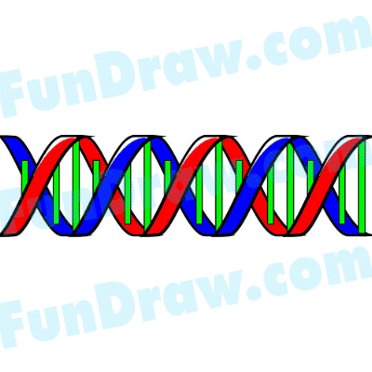

_________________ ______________, a shape that we recognize as DNA.

On the ________ _____________ or __________ ________________the rails of the ladder are made from alternating sugar and phosphate; the rungs of the ladder are made from nucleotide base-pairs.

The nucleotide bases on DNA are ________________, __________________

_____________________, and ___________________

They always bond according to the _________ - ________ _______: A-T and G-C.
draw picture

