Last name:___________________ First name:____________________ Date:______________ Period:____
Conservation of Mass Intro

Phenomena Brainstorm:
Why does a campfire start out as a big pile of logs but ends as a smaller pile of ashes?

Describe & model:
Where did the matter for this tree come from as it grew? Write your ideas on the arrow below.

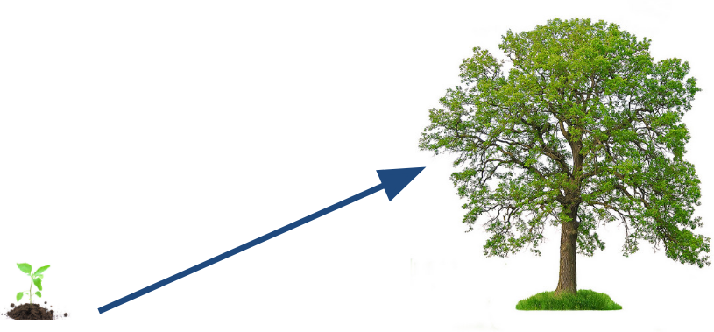

Vocabulary:
Conserve | To _______________________________ of something
Mass | A measure of _______________________________ is present in a substance | 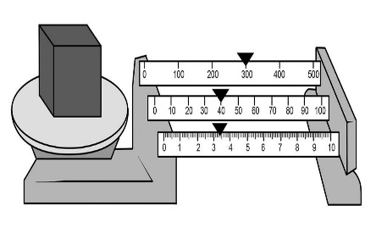
Law of Conservation of Mass | The mass of all _________________ must equal the mass of all _________________. Matter is neither _________________ nor _________________. | 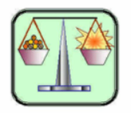
Scenario
The Rodriguez family roasted marshmallows over a campfire one night. They noticed that they all had to help carry the logs to the backyard, but only one of them had to sweep up the ashes and carry them away.

External Data
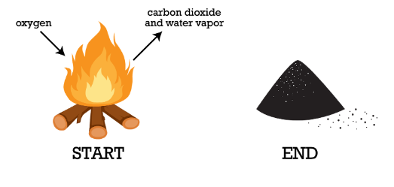
Write a scientific explanation using the law of conservation of mass to explain what happened to the atoms in the logs.

Claim:

Evidence:

Reasoning:

