Name _______________________
Period__Date_________________

CONDENSATION Mini Lab 1

Question to investigate?
What happens when water vapor condenses?

Materials for you and your elbow partner:
- 1 short wide-rimmed clear plastic cup
- 1 tall smaller-rimmed clear plastic cup
- Hot water (about 50ºC 122ºF) from the burner.
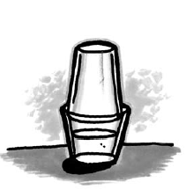
Procedure
1. Fill a wide clear plastic cup about 2/3 full of hot
tap water from the burner.
2. Place the TALL cup upside down inside the rim of
the bottom cup as shown.
3. Watch the cups for about 2 minutes.
4. Take the top cup off and feel the inside surface.
5. Do NOT dump the water out.

What did you observe?
6. After a couple of minutes, what did you observe on’
the inside of the top cup?_______________________________________________
7. The water molecules in the bottom cup evaporated into a gas and then condensed to form liquid water on the inside of the top cup. Since the water molecules were all separated as a gas, why did they come together to form a liquid? Think “transfer of energy, speed of molecules, and attractions.
__________________________________________________________________
__________________________________________________________________
8. Draw a diagram showing the motion/spacing/attraction of the molecules.

in the bottom cup (liquid) as it is evaporating (gas) the particles on the side of the top cup

CONDENSATION Mini Lab 2

Question to investigate:
If colored water evaporates and condenses, will there be any color in the water that is produced? What do you think—circle one YES NO

Materials for you and your elbow partner
- 1 short wide-rimmed clear plastic cup
- 1 tall smaller-rimmed clear plastic cup
- Hot tap water from the faucet
- Food coloring
- Ice Cube
- Paper Towel
- Stirring stick

Procedure:
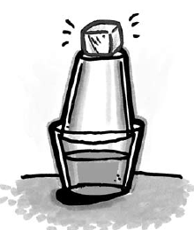
1. Add 1 drop of food coloring to the bottom cup
of hot water.
2. With the stirring stick, stir until the water is
completely colored.
3. Turn another clear plastic cup upside down on
the cup of hot water as shown.
4. Place an ice cube on the top cup to make
condensation happen faster.
5. Wait 2-3 minutes for water vapor to condense
to liquid water on the inside surface of the top cup.
6. Use a white tissue to wipe the inside of the cup to check for any color.

What did you observe?:
7. Is there any color in the water that forms on the inside of the top cup?____________

8. If you were stranded on an island and only had saltwater, how could you make water to drink? Describe in detail._______________________________________________
__________________________________________________________________
__________________________________________________________________
__________________________________________________________________
__________________________________________________________________
__________________________________________________________________

