Last name:___________________ First name:___________________ Date:________________ Period:_____
Chemical Rxns –

Burning Magnesium Demo
Write an observation about the reactant (Magnesium Mg)

Write an observation about the product(Magnesium oxide MgO)

What is the other reactant besides Magnesium?

How do you know a chemical reaction took place?
Write 1-2 complete sentences explaining what you observed that indicates there was a chemical change.
(Hint: Remember the 4 clues)

Write a balanced chemical equation for the reaction.
(Hint: The total number of atoms on each side must be the same before and after.)

___Mg + O₂ ___MgO

Chemical Formulas/Counting Atoms
NUMBER OF EACH ATOM
____Fe ____Br
____H ____N ____O
____H ____O
____N ____H ____Cl
____Na ____C ____H ____O
____Fe ____O

CHEMICAL FORMULA
#1 – FeBr3
#2 – 2HNO₃
#3 - 2H₂O
#4 – 4NH₄Cl
#5 – 2NaC₂H₃O₂
#6 - 2Fe₂O₃

Photosynthesis/Cellular Respiration Review
QUESTION | ANSWER
- Write the reactants of photosynthesis.
- Write the products of photosynthesis.
- Is this an endothermic or exothermic reaction? Why?
- Write the reactants of cellular respiration.
- Write the products of cellular respiration.
- Is this an endothermic or exothermic reaction? Why?
- What do you notice about the two equations?
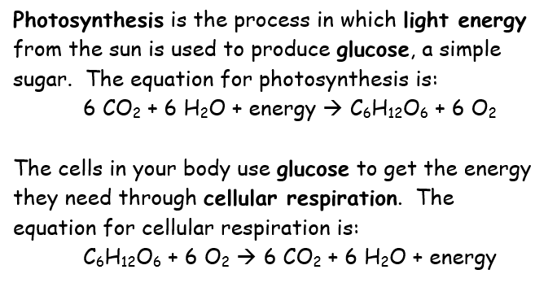
STATION 2
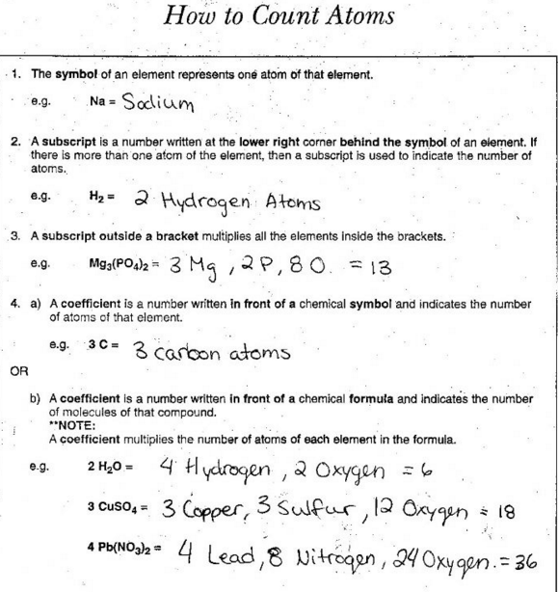

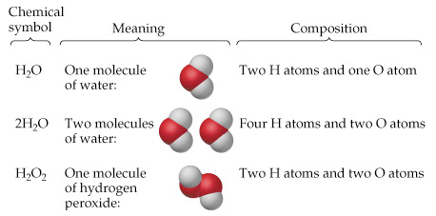

CHEMICAL FORMULA
#1 - Mg(OH)₂
#2 - Al₂(SO₄)₃
#3 - 2H₂O
#4 - Ca₂Mg₂(SiO₄)₂(OH)₂ (Asbestos)
#5 - C₂H₄(OH)₂ (Antifreeze)
#6 - 2Fe₂O₃

STATION 3

Photosynthesis is the process in which light energy from the sun is used to produce glucose, a simple sugar. The equation for photosynthesis is:
6 CO₂ + 6 H₂O + energy C₆H₁₂O₆ + 6 O₂

The cells in your body use glucose to get the energy they need through cellular respiration. The equation for cellular respiration is:
C₆H₁₂O₆ + 6 O₂ 6 CO₂ + 6 H₂O + energy

Reactants = starting materials in a chemical reaction
Products = substances formed from a reaction

Endothermic = energy is absorbed (added) during the reaction (requires energy)
Exothermic = energy is released or removed during the reaction

STATION 1: Burning Magnesium Demo
(make-up help)
Write an observation about the reactant (Magnesium). | Silver  Shiny  Solid  Malleable
Write an observation about the product (Magnesium oxide). | Brittle  White solid  Looks like ash
What is the other reactant besides Magnesium? | Hint:  What is in the air that causes a fire to burn?
How do you know a chemical reaction took place?  Write 1-2 complete sentences explaining what you observed that indicates there was a chemical change.  (Hint: Remember the 4 clues) | Did a new substance with new properties form? How do you know?  Important observations:  Smoke  A bright white light was given off
Write a balanced chemical equation for the reaction.
(Hint: The total number of atoms on each side must be the same before and after.)

Reactant 1 + Reactant 2 Product

