Name____________________
I CAN identify and explain how each part of a eukaryotic cell works.

Period ___ Date ____________

THOSE CHEEKY LITTLE CELLS

Read a step and then do it. Then read the next step and do it. Continue on reading each step before doing it.

1. Take a slide and a cover slip out of the case and clean them with a paper napkin, using a little water from the dropper.

2. Place the slide flat on the index card provided AND place a TINY drop of blue dye on the slide.

3. Take a NEW toothpick and GENTLY SWAB the inside of your cheek (this will remove some loose epithelial cells).

4. Dip your swabbed toothpick into the dye on your slide and twirl it (to release the cells into the dye).

5. Wrap toothpick in the napkin you cleaned the slide with and place into the waste container on your table. NEVER PUT THIS USED TOOTHPICK BACK IN YOUR MOUTH.

6. Lay one edge of coverslip on slide and then drop it so that the whole area under the coverslip is filled with liquid with NO air bubbles.
If any liquid in ON TOP of the coverslip, gently blot away with napkin, or make a new slide. DO NOT USE A SLIDE WITH DYE ON TOP OF THE COVERSLIP!

7. Follow microscope 6 Quick Steps to Remember.
You are viewing on the 4x objective lens.

8. When you have the edge of the coverslip in focus, move the slide to scan for cheek cells (tiny irregular blue fragments).

9. Avoid regular round objects (air bubbles) and dark blue chunks.
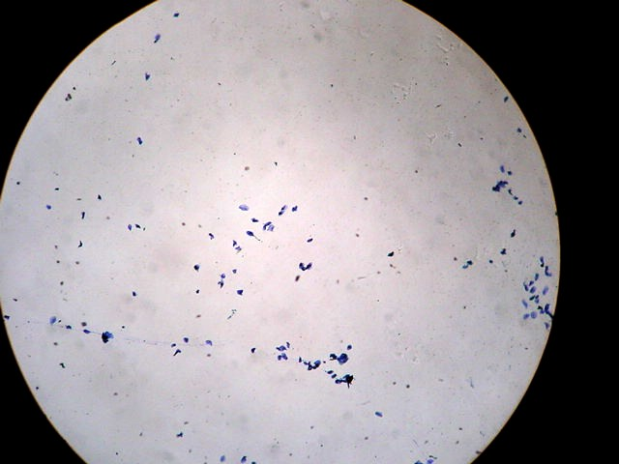
cheek cells 4x * 10x = 40x

10. When you think you have cheek cells in the CENTER of your field of view, go to the 10x objective lens and observe. ONLY USE FINE FOCUS KNOB.
cheek cells 10x * 10x = 100x

11. Scan around with the 10x objective until you find ONE cheek cell by itself (NOT clumped up with the others).

12. Center the cell in your field of view, then switch to the 40x objective lens and focus ONLY USING THE FINE FOCUS KNOB!!!!

13. Draw a larger SKETCH of the cheek cell below and LABEL the following:
- the magnification 10x * 40x = 400x
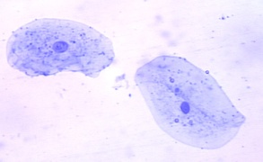
- the name of the cell HUMAN CHEEK CELL
- the CELL MEMBRANE
- the NUCLEUS (the dark spot)
cheek cells at 40x * 10x = 400x
- the CYTOPLASM (fluid and materials inside the cell)

- Write at least 2 observations about this animal cell--in complete sentences.

- Comparing the plant cells we looked at yesterday--Write down two things that a plant cell has that an animal cell does NOT.

