MAKE UP CHEEK CELL AND ELODEA LAB
On a piece of blank paper, copy one cheek cell and one elodea cell.
Label as indicated.
Write two observations of each cell in complete sentences.

HUMAN CHEEK CELL 10x X 40x = 400x
cytoplasm
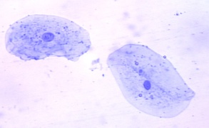

nucleus
cell membrane

ELODEA CELL 10x X 40x = 400x
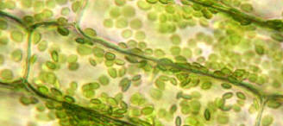
chloroplasts
cytoplasm
cell membrane
cell wall

