Name____________________
P__________Date__________

Board Game: Photosynthesis & Cellular Respiration
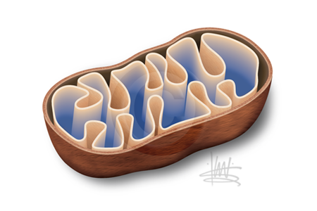
50-45 Mastery
44-40 Advanced
39-35 Meets
34-30 Approaching
29 or less Beginning

Assignment:
- You are a board game manufacturer, and you have been assigned the task of creating a board game that will help students review everything they know about photosynthesis & cellular respiration in a fun and interesting way.

Requirements:
- Using note cards and colored pencils, create a game board.
- Put the name of your game on the tab of the folder and decorate the inside so that it is a game board.
- Make it neat, colorful, interesting, and creative.

______Create at least 10 questions and answers about photosynthesis and cellular respiration.
You must have at least 5 questions on photosynthesis AND
5 questions on cellular respiration. (20 Points)

______Design/Decoration: Your game must in some way relate to photosynthesis & cellular
respiration. Example: Game board involves plants, animals, cells, sunlight glucose, chloroplasts, mitochondria, etc. You can draw pictures on the board or on the back of the cards. (10 points)

_______Content and Difficulty (5 points)

_______Format: You should have a clear start and finish. Some spaces should have instructions.
For example: Skip a turn, Move 1 space forward, Move 2 spaces backwards. (5 points)

_______ Creativity and Effort (10 points possible)
