This is an artifact.

DO NOT write on this document.

**I CAN** explain and describe how animal & plant cells produce more cells.

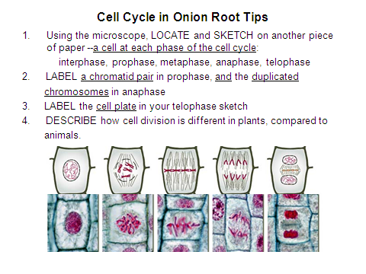

Plankenhorn