Name ___________________________
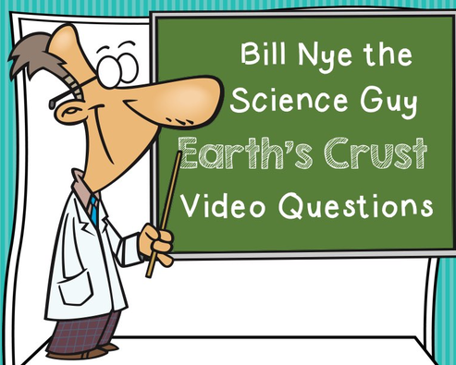

Period_____Date__________________

Before the video, list three things you know about the Earth’s Crust:
_____________________________________________________________________________________________________________________________________________________________________________________________________________________
Answer the following questions during/after watching the video.
1. The earth’s crust is made of ________________________________.
2. All living things live on/below the earth’s crust.
3. The first layer under the crust is called the ____________________.
4. The person that studies volcanos is called a __________________________.
5. Mount St. Helen’s is an ________________________volcano.
6. _____________________is pushed out of a volcano by the buildup of ___________.
7. The crust is the ___________________layer of the earth.
8. A ____________________is like a volcano but shoots out hot, steamy water.
9. _________________builds up and forces water out of the geyser.
10. Earth’s ____________________plates float on the mantle.
11. Tectonic is from the Latin word for ________________.
12. North America is moving away from Europe about an ______________a year.
13. All of earth’s plates were once together. This is know as ________________ which
means the ___________________ ______________________.
14. ________________ are hollow spaces in the earth’s crust.
15. When the earth’s plates shift, the result is a(n) _______________________.
16. The instrument that monitors an earthquake is called a _____________________.
17. The ___________________is the thinnest layer of the earth.

After the video, list three things you know now because of the video but you did not know before:
_____________________________________________________________________________________________________________________________________________________________________________________________________________________
