Name ___________________________
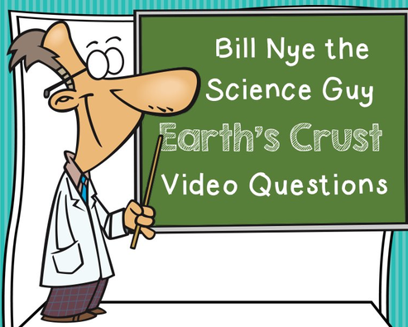

Period_____Date__________________

Before the video, list three things you know about the Earth’s Crust:
_____________________________________________________________________________________________________________________________________________________________________________________________________________________
Answer the following questions during/after watching the video.
1. The earth’s crust is made of SOLID ROCK.
2. All living things live on/below the earth’s crust.
3. The first layer under the crust is called the MANTLE.
4. The person that studies volcanos is called a VOLCANOLOGIST.
5. Mount St. Helen’s is an EXPLOSIVE volcano.
6. LAVA is pushed out of a volcano by the buildup of GAS.
7. The crust is the THINNEST layer of the earth.
8. A GEYSER is like a volcano but shoots out hot, steamy water.
9. PRESSURE builds up and forces water out of the geyser.
10. Earth’s TECTONIC plates float on the mantle.
11. Tectonic is from the Latin word for BUILD.
12. North America is moving away from Europe about an INCH a year.
13. All of earth’s plates were once together. This is know as PANGAEA which
means the WHOLE EARTH.
14. CAVES are hollow spaces in the earth’s crust.
15. When the earth’s plates shift, the result is a(n) EARTHQUAKE.
16. The instrument that monitors an earthquake is called a SEISMOGRAPH.
17. The CRUST is the thinnest layer of the earth.

After the video, list three things you know now because of the video but you did not know before:
_____________________________________________________________________________________________________________________________________________________________________________________________________________________
