Name _________________________________
Period_____Date________________________
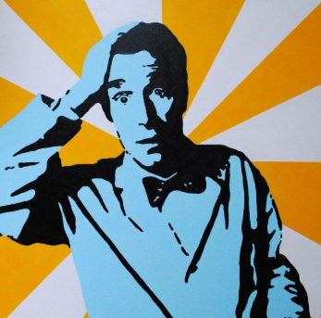
Bill Nye: Chemical Reactions

- When some chemicals get together they ______________________________.
- Chemical reactions happen when ______________________________hook together.
- When oxygen and steel wool reacted, ______________________________was given off when the electrons recombined with other electrons.
- Fire is a reaction between chemicals in _____________________________with __________________________ in the air, which gives off ___________________________.
- In the homemade fire extinguisher, the reaction of baking soda and vinegar makes ______________________________that puts out flame.
- When deadly ______________________________and ______________________________ join together they form delicious ______________________________, or salt.
- The color and twinkling of fireworks depends on the specific _________________________ or _________________________ that is burned.
- When baking soda and water react with heat, ______________________________ of carbon dioxide are produced which help make a cake fluffy.
- An ice pack works because when the chemicals inside it mix, the reaction takes up energy in the form of _____________________, so what you feel is _________________________.
- Write 3 examples of chemical reactions from the video that are not mentioned above.
1.
2.
3.

