Mark with the following CODES:
! This is important
✔ I knew that.
X This is different from what I thought.
? I don’t understand.
Name______________________________
Period___Date_______________________

Bacteria: The Good, the Bad, and Getting Rid of the Ugly
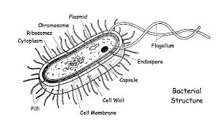

Bacteria are everywhere. A teaspoon
of soil can have as many as a million bacteria.
Your skin is home to 100 billion. And that
doesn’t even begin to cover what can be
found in your mouth or intestines.
If you look closely at your skin, you
won’t see any bacteria. A single bacterium
can only be seen with a high-powered
microscope. Each bacterium is made of just one
simple cell.
Bacteria are prokaryotes, which means
that they do not have a nucleus. Instead, they have a tangle of DNA that floats in the cytoplasm. They lack other organelles, too, such as Golgi bodies, endoplasmic reticulum, and vacuoles.
But as their numbers show, simple doesn’t mean the bacteria aren’t successful. Bacteria species survive in almost every imaginable place: our bodies, the ice in Antarctica, rotting wood, and even barrels of poisonous chemicals.

Not So Deadly
When most people think of bacteria, they think of disease. Bacteria cause a variety of human diseases, such as strep throat, whooping cough, and anthrax. But only about 4% of bacterial species are pathogens, or organisms that cause disease. Many bacteria are actually helpful to humans.
Your intestines are filled with bacteria that help with an important task—digesting your food. Our digestive system can’t break down all of the food we eat, so the bacteria in our intestines dine on the leftovers. We provide food and housing for them, but they give us a lot in return. One of the most common bacteria in our intestines, E. coli, makes vitamin K, which helps our blood clot. It also makes folic acid, which helps prevent birth defects.
Another common intestinal bacteria, Lactobacillus acidophilus, protects our intestines from other bacteria and fungi that cause disease. L. acidophilus is found in yogurt. When you take antibiotics for an illness, those antibiotics also kill L. acidophilus. Eating yogurt can help replenish your supply.

Helpful Hunger
Wherever bacteria live, they have to find something to eat. Bacteria have evolved to eat just about everything. Humans are learning to take advantage of this to clean up pollution.
As you can imagine, gas stations have the ability to produce a lot of pollution. At a gas station, the storage tanks for gasoline are buried underground. After about fifteen years, the tanks get old and may begin to leak. Gasoline in the environment separates into several different chemicals, some of which cause cancer. Scientists who study bacteria, called microbiologists, have discovered bacteria that can digest the cancer-causing chemicals. These bacteria can be used to clean up leaked gasoline.

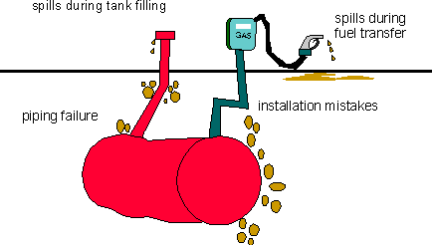

Microbiologists have found bacteria that eat other pollutants as well. There are bacteria that digest poisonous cyanide, pesticides, old paint, and even oil spills. The process is slow, but bacteria are being used to clean up polluted places all around the world.

Agar-den of Bacteria
Microbiologists have found ways to grow bacteria in the lab so they can study them. One common way to grow bacteria is to put them on an agar plate. An agar plate contains a jellylike substance (agar) and the nutrients that bacteria need in order to grow.
Individual bacteria cannot be seen when they are rubbed onto an agar plate with a cotton swab. But the bacteria begin to reproduce very quickly. In just a day or two, one bacterium will divide enough times to make a clump of bacteria that can be seen by the naked eye. These clumps are called colonies. Each bacterial colony consists of thousands or even millions of bacteria that came from one original bacterium.
Not all types of bacteria grow well on agar, but most of the ones that live on and around humans grow nicely. You can use an agar plate to see some of the millions of bacteria in the world around you.
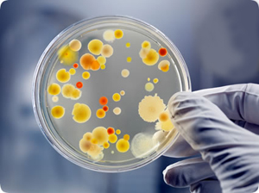

THE BIG QUESTION
- Many people think all bacteria cause disease. After reading this article, do you think that all
bacteria causes disease? ______(answer yes or no)
- Write a paragraph,(3-5 sentences) below or on a separate piece of notebook paper that supports your answer with information from the article.

