Name __________________________
Bacteria, Animal and Plant Cells

P. ___Date______________________

1. Place TWO labels on each picture describing its cell type choosing from these words:
Eukaryote, prokaryote, animal, plant, bacteria
2. Choosing from the following words, explain in note form characteristics that identifies this cell.
Nucleus, no nucleus, cell wall, no cell wall, chloroplasts, large vacuole (you may use the work more than once)

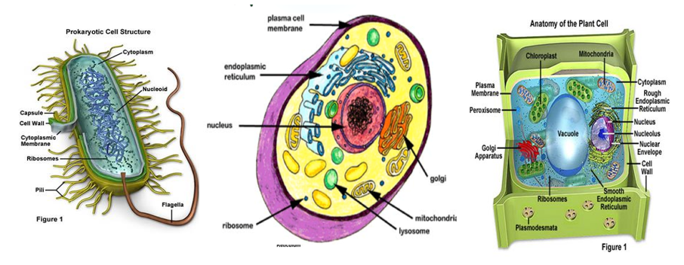
Label: ________________________ Label: ____________________________ Label: __________________________
________________________ ____________________________ __________________________
Characteriestic: Characteriestics: Characteriestics:
______________________________ ___________________________________ ________________________________
___________________________________ ________________________________
________________________________
________________________________

