Name _________________________
I CAN describe the structures and functions of vascular plants (angiosperms).
Period___Date__________________

look at diagram p. 290
ANGIOSPERM REPRODUCTION

C
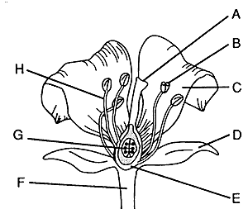
G

H

F

B

I
E

D

1. Where is the pollen formed?____________________________________
2. Where is the egg formed?______________________________________
3. Where does fertilization take place?______________________________
4. Which part will become the fruit?_________________________________
5. Which part will become the seed?_______________________________
6. Label all of the letters in the above diagram.
B is the collective name for all the female parts of the flower.
Hint: the individual female parts are letters A, C and D, E.
F is the collective name for all the male parts of the flower.
Hint: the individual male parts are letters, G and H
I is the leaflike structure that covers and protects an immature flower.
7. With a red pen--draw a pollen tube in the above diagram.

