Name__________________________________

Period____Date__________________________

AMOEBA SISTERS: VIDEO RECAP | MITOSIS: THE AMAZING CELL PROCESS THAT USES DIVISION TOMULTIPLY

Amoeba Sisters Video Recap of Mitosis: The Amazing Cell Process That Uses Division to Multiply

1. Mitosis is done by your body cells. This cartoon illustrates an exception. What types of cells do not undergo mitosis?  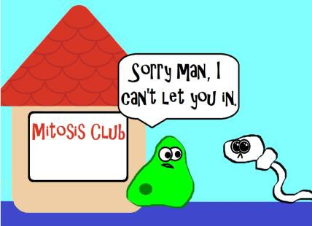 | 2. Describe how mitosis is important for your body.  _______________________  _______________________  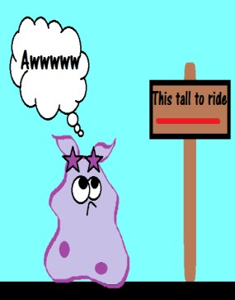  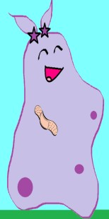 | 3. This illustration is trying to demonstrate something that mitosis is not. In mitosis, the cells that are created  are  _________________________  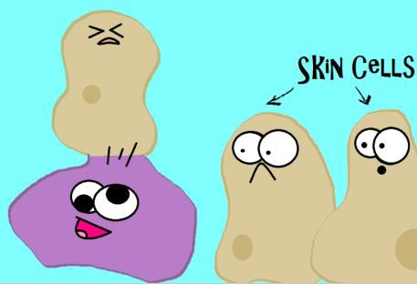
4. Mitosis is just one small part of the cell cycle! Describe what would occur if cells were in mitosis more than they were in interphase.  ____________________________  ____________________________  ____________________________  ____________________________  ____________________________  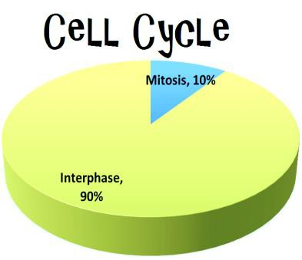 | 5. When cells are dividing, it is important to understand that they have to move chromosomes equally to both cells. Based on this illustration, describe what a chromosome is made of.  ____________________________  ____________________________  ____________________________  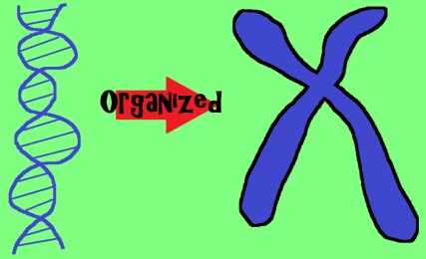 | 6. Mitosis starts and ends with diploid cells. That means they have two sets of chromosomes (both parents each contribute a set). In humans, how many chromosomes should be in each of these diploid cells after mitosis?  ____________________________  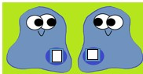

AMOEBA SISTERS: VIDEO RECAP | MITOSIS: THE AMAZING CELL PROCESS THAT USES DIVISION TO  MULTIPLY

Sketch the Mitotic Stages

Directions: We encourage you to be creative with a cartoon illustration of your own for each phase. Label the chromosomes, spindles, and nucleus (if applicable).
CELL CYCLE
INTERPHASE
MITOSIS
prophase
metaphase
anaphase
telophase
CYTOKINESIS
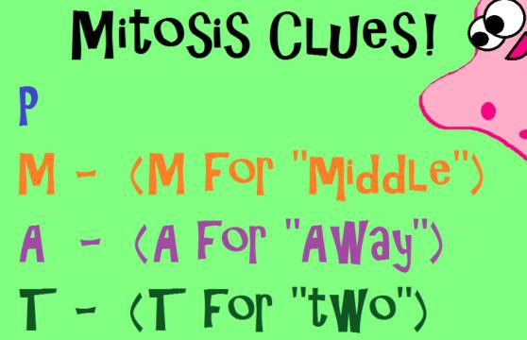

Prophase | Metaphase
Anaphase | Telophase

BECKY NOTES:

In this video:
- Prophase is described as still having a nuclear membrane –and that it disappears during metaphase. I teach the steps that during Prophase the nuclear membrane disappears.
- Telephase is described as the step in which the two identical cells split in two. I teach that the cell pinches inward (plant cells –cell plate) and that when the cytoplasm splits in two—it is called cytopkinesis.

