THIS FORM AND MONEY DUE
FRIDAY, MAY 26TH!

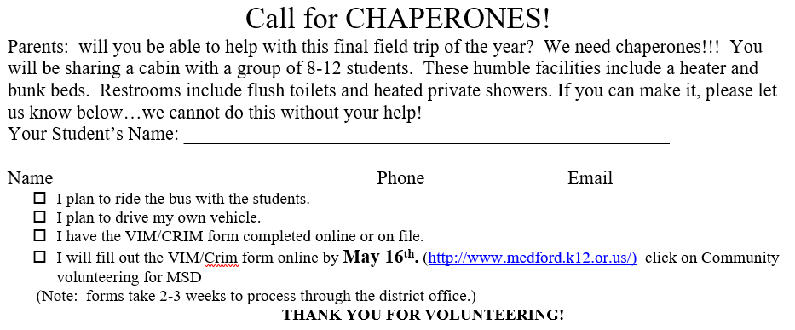

Required Field Trips: The Medford School District never wants financial circumstances to be a barrier to a student’s education. We encourage families to support the field trip with the donation requested below.
The field trip fee will be provided by the District for families for whom this is a hardship.

Questions: Contact Mrs. Hansen at peg.hansen@medford.k12.or.us

_______________________________________ has permission to attend the Mountain Lakes Camp
(student name)
field trip with Team 7-3.

Signed: ___________________________/_________Emergency contact number: ______________
parent or guardian signature date

List any medical, dietary and other concerns that are important to share with us:
________________________________________________________________________________

________________________________________________________________________________

- I have included $55.00.
- I have included $55.00 and $ ________for financial assistance for another student(s).
- My child needs financial assistance. We can contribute $________towards the $55.00 fee.
- My child will participate in the Nature’s Vision Fund Raiser.

