Use the terms from the “States of Matter” lesson to complete the puzzle.
Across: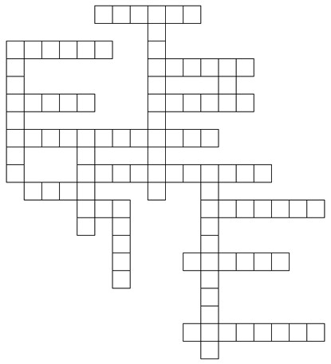
1
2
3
6
8
4
5
7
9
10
12
11
15
13
14
16
17
1
. Another term for states
3
. State of matter found in stars
4. State of matter with a fixed volume, but no
Down:
- Gas changing into a solid or a solid changing
into a gas; no liquid phase
- A change in state is a ____ change.
5. Solid state of water
9. Solids have the lowest amount of _____.
11. Changing ___ causes a change in state
14. State of matter with a fixed volume
and shape
fixed shape.
- Gaseous state of water
- Anything that has mass and occupies space
- Gas changing into a liquid, such as water vapor
changing into water
10. Liquid changing into a gas, such as water
changing into water vapor
12. There are __ states of matter including plasma.
13. State of matter with no fixed volume of shape.
- Solid changing into a liquid, such as ice changing to water
- Solid state of carbon dioxide
- Liquid changing into a solid, such as water changing to ice

