MARK YOUR CALENDARS!
FIRST TWO FIELD TRIPS OF THE YEAR-TEAM 7.3
$5.00 covers both field trips!
Field Trip 1-Mini Maker Faire in Ashland
At Science Works – Friday, September 22nd
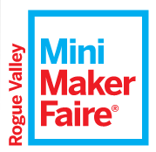

We call this the Greatest Show (& Tell) on Earth
A showcase of invention, creativity, and resourcefulness
Glimpse the future and get inspired!

Students will learn about creative hobbies, experiments, and projects from local engineers, artists, scientists and crafters!

Who: ALL Team 7.3 Hedrick Middle School students
Date/Time: September 22nd 10:00 AM load buses & depart at 10:15 AM (Return by 1:45 PM)
Location: Science Works, 1500 E. Main Street, Ashland, OR 97520
What to Bring: Pencil and Composition Book
Sack Lunch from home or school provided sack lunch and
refillable water bottle

__________________________________________________________________________________________
Field Trip 2-FORT VANNOY FARMS
in Grants Pass
Wednesday, October 11th
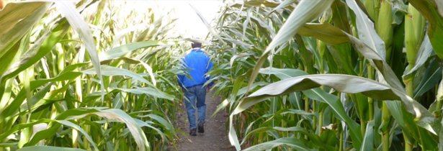
Students will learn:
- how plants are the most important storage of energy
- about daily life on a farm
Sponsored by the Agri-Business
Council of Oregon

- farming career opportunities
- and can you complete the Corn Maze challenge?

Wear appropriate walking shoes that can get dirty/muddy (depending on the weather) and wear layers for warmth. NO FLIP-FLOPS!

Who: ALLTeam 7.3 Hedrick Middle School students
Date/Time: October 11th 9:25 AM load buses and depart at 9:35 AM (Return by 3:15 PM)
Location: Fort Vannoy Farms, 5791 Lower River Road, Grants Pass
What to Bring: Sack Lunch from home or school provided sack lunch and
refillable water bottle

Please complete and return this page and $5 with your child
ON MONDAY, SEPTEMBER 18TH!

_______________________________has permission to attend the Mini Maker Faire field trip on September 22nd AND the Fort Vannoy farm field trip on October 11th.

Signed:_____________________________/_______Emergency contact number:_______________________

List any medical, dietary and other concerns that are important to share with us:

_______________________________________________________________________

_______________________________________________________________________

Payment/Scholarships
The Medford School District never wants financial circumstances to be a barrier to a student’s education. We encourage families to support the school programs by paying the standard fees. Any family that qualifies for free and reduced meals is exempt from school fees that provide access to the regular school program.

Every year we have many students that request field trip scholarships. If you are able to help another student, thank you for including additional funds.

I have included $5

I have included $5 and $_______for scholarship(s) for another student(s).

My child needs a scholarship. I have given a brief explanation why on the back of this slip.

My child will bring a sack lunch from home for both field trips.

My child will NEED a cafeteria sack lunch for both field trips.

CHAPERONES!
This is the first of several field trips we are planning this year. We will need several parent volunteers to accompany us on both trips. We invite you to join us, as you are what helps to assure that these trips are a success. We need chaperones!!!

If interested, please check below and return the bottom portion of this form
By Monday, September 22nd.

I would like to chaperone the Mini Maker Faire on September 22nd and will complete necessary VIMS process on the Medford School District website.

I would like to chaperone the Fort Vannoy farm field trip on October 11th and will complete necessary VIMS process on the Medford School District website.

Parent Chaperone Name _______________________________________________________

Student Name _______________________________________________________________

Phone Number _______________________________________

